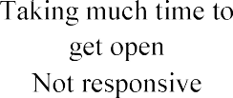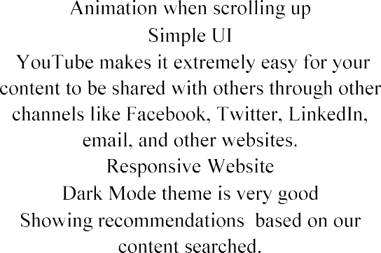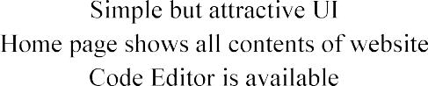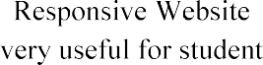

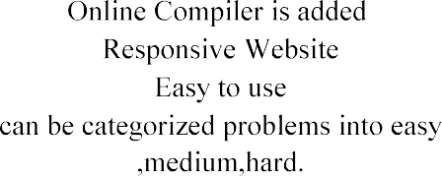

|  |  |  |  |  |  |
| --- | --- | --- | --- | --- | --- |
|  |  |  |  |  |  |
|  |  |  |  |  |  |
|  |  |
|  |  |  |  |  |  |
|  |
|  |
|  |
|  |
|  |  |  |  |  |  |
|  |
|  |  |
|  |
|  |
|  |  |  |  |  |  |
|  |
|  |
|  |  |
|  |
|  |
|  | www.reddit.com | Entertainment / new purpose |  | Recaptcha message doesn’t go away after verification. | Good |
|  | Takes up lot of cache memory |
|  |
|  |  |  |  |  |  |